Chapter 2, Solution 80

The amplifier can be modeled as a voltage source and the loudspeaker as a resistor:

-
+
V
R₁
Case 1
-
+
V
R₂
Case 2

Hence 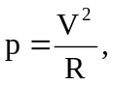 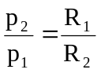 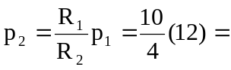 30 W

